Partial / residual correlation: EURUSD and USDCAD
Method 07 / daily log returns / leave-currency-out USD factor / Alpari D1 full available history

Study setup
Logical pair: EURUSD , USDCAD
Broker symbols: EURUSD_i , USDCAD_i
Snapshot: 2026-11-03_majors_alpari_D1
Timeframe: D1
Matched return window: 1999-01-05 to 2026-11-02 (UTC bar dates)
Matched return count n: 7148
Dropped unfinished last bar dated 2026-11-03 UTC after a tick-volume check against the prior complete day.
USD-strength sign rule: minus log return when USD is the quote (EURUSD, GBPUSD, AUDUSD, NZDUSD); plus log return when USD is the base (USDJPY, USDCHF, USDCAD). EURGBP is never a constituent.
Control z constituents (5): GBPUSD, AUDUSD, NZDUSD, USDJPY, USDCHF
z_t = equal-weight mean of those USD-strength returns on the same day
Complete matched rows (Excel): EURUSD-USDCAD_Partial_D1.xlsx
Complete matched rows (HTML table): EURUSD-USDCAD_Partial_D1_data.html

Method carried forward
Partial / residual correlation regresses each matched daily log return of close, ln(close_t / close_t-1), on the same leave-currency-out USD strength factor z, then takes Pearson correlation of the two residual series. Quotes are not inverted. z is the equal-weight mean of USD-strength returns from other majors that do not share a non-USD currency with either leg; EURGBP is never a constituent. USD-strength is minus the log return when USD is the quote (EURUSD, GBPUSD, AUDUSD, NZDUSD) and plus the log return when USD is the base (USDJPY, USDCHF, USDCAD). OLS uses an intercept on each leg. rho_partial is symmetric under swap of the two symbols. It describes leftover linear co-movement after removing linear z; it is not a cause, not a lead, and not a trading signal. Daily rows are not independent and residuals are estimated, so the two-sided p-value and Fisher interval are secondary. Same-sample raw Pearson r is a side check only.

Regression on z
leg | intercept_a_or_c | slope_b_or_d | R2
EURUSD | -1.086e-05 | -0.91393338 | 0.59366277
USDCAD | -6.47e-06 | 0.60819816 | 0.33423272

Results
rho_partial: -0.022343
Two-sided p-value: 0.0588979
Approximate 95% Fisher interval: [-0.045503, 0.000840]
Same-sample raw Pearson r: -0.457067
rho_partial minus r: 0.434723

Conclusion
Over 7148 matched daily rows for EURUSD and USDCAD after removing a leave-currency-out USD factor built from 5 constituents, rho_partial is -0.0223 (negative, weak residual linear link in this sample). Approximate 95% Fisher interval: [-0.0455, 0.0008]. Same-sample raw Pearson r is -0.4571 (partial minus r = 0.4347). Leg R-squared on z: EURUSD=0.5937, USDCAD=0.3342. Two-sided p under the usual independent-pairs model is 0.0589; residuals are estimated and daily FX rows are linked, so treat p as secondary. This does not establish cause, lead-lag, or a lasting trading rule.

Charts
Daily closes
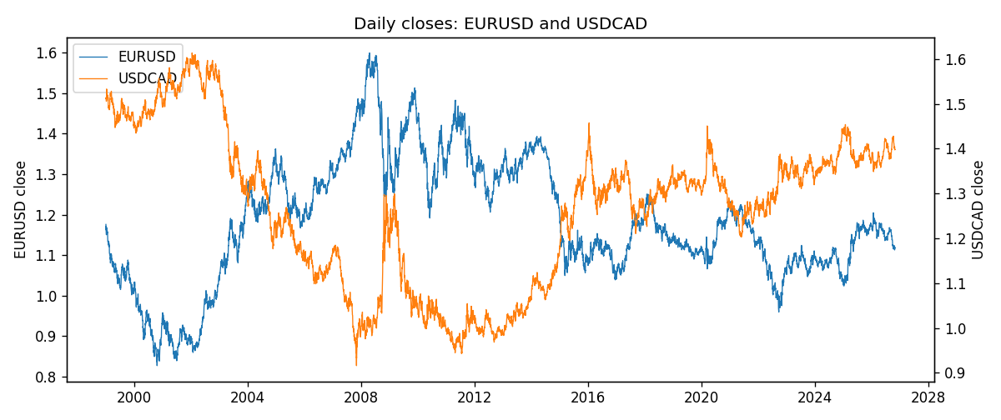
Log returns and control z
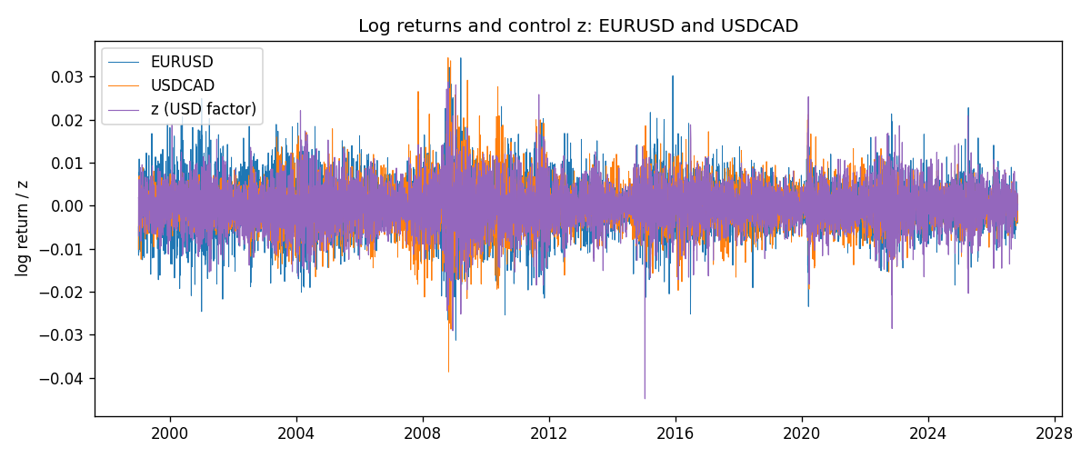
Residual scatter e_x vs e_y
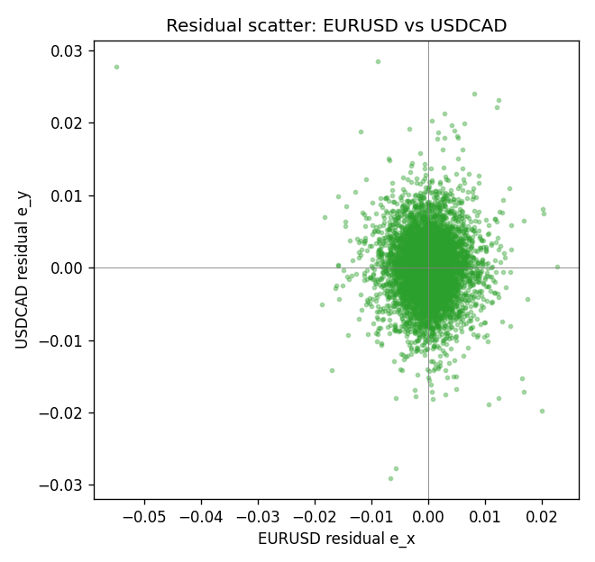

Data report
Every matched row that entered the partial correlation is stored in the sibling Excel workbook named EURUSD-USDCAD_Partial_D1.xlsx. That file is the complete data archive for redrawing charts. Embedding all rows as a Word table is impractical at this length; the Word file holds the column list, column summaries, and the first and last 15 matched rows.
Columns: time, EURUSD_open, USDCAD_open, EURUSD_high, USDCAD_high, EURUSD_low, USDCAD_low, EURUSD_close, USDCAD_close, EURUSD_tick_volume, USDCAD_tick_volume, EURUSD_spread, USDCAD_spread, EURUSD_real_volume, USDCAD_real_volume, EURUSD_log_return, USDCAD_log_return, usd_strength_GBPUSD, usd_strength_AUDUSD, usd_strength_NZDUSD, usd_strength_USDJPY, usd_strength_USDCHF, z, EURUSD_fitted, USDCAD_fitted, EURUSD_resid, USDCAD_resid
Column summaries (matched calculation rows)
column | count | mean | std | min | 25% | 50% | 75% | max
EURUSD_open | 7148 | 1.1816879 | 0.15074041 | 0.8272 | 1.0863875 | 1.16609 | 1.2942 | 1.5995
USDCAD_open | 7148 | 1.2664001 | 0.16881677 | 0.9168 | 1.1174225 | 1.29842 | 1.3719025 | 1.6183
EURUSD_high | 7148 | 1.1868219 | 0.15134312 | 0.8326 | 1.0904675 | 1.17121 | 1.29957 | 1.6038
USDCAD_high | 7148 | 1.2712993 | 0.16876756 | 0.9336 | 1.1224 | 1.30385 | 1.3760825 | 1.619
EURUSD_low | 7148 | 1.1766784 | 0.15005373 | 0.8227 | 1.0822025 | 1.162475 | 1.2886225 | 1.5865
USDCAD_low | 7148 | 1.2618444 | 0.16884966 | 0.9056 | 1.1128375 | 1.29351 | 1.367575 | 1.6102
EURUSD_close | 7148 | 1.1817317 | 0.15070664 | 0.8267 | 1.0862225 | 1.16602 | 1.2942 | 1.5997
USDCAD_close | 7148 | 1.2664179 | 0.16878481 | 0.916 | 1.117435 | 1.298405 | 1.3722025 | 1.6137
EURUSD_tick_volume | 7148 | 103711.54 | 173856.26 | 469 | 9484.75 | 52998 | 99801.75 | 1471626
USDCAD_tick_volume | 7148 | 81445.79 | 147602.47 | 56 | 5642.25 | 41126 | 71764.5 | 1410818
EURUSD_spread | 7148 | 19.246223 | 16.509774 | 0 | 8 | 12 | 20 | 50
USDCAD_spread | 7148 | 23.322888 | 18.222444 | 0 | 9 | 17 | 40 | 60
EURUSD_real_volume | 7148 | 4.0536992e+10 | 1.6733469e+11 | 0 | 0 | 0 | 0 | 3.6149665e+12
USDCAD_real_volume | 7148 | 1.8476363e+10 | 9.6948735e+10 | 0 | 0 | 0 | 0 | 2.5751613e+12
EURUSD_log_return | 7148 | -2.16e-06 | 0.0058013 | -0.03123819 | -0.00324218 | 0 | 0.00325609 | 0.03433183
USDCAD_log_return | 7148 | -1.226e-05 | 0.00514518 | -0.03859748 | -0.00283513 | 4.873e-05 | 0.00272781 | 0.03436319
usd_strength_GBPUSD | 7148 | 1.992e-05 | 0.00564699 | -0.03112653 | -0.00318167 | -3.426e-05 | 0.0031217 | 0.08388241
usd_strength_AUDUSD | 7148 | -3.157e-05 | 0.00755018 | -0.0806166 | -0.00415111 | -0.00029168 | 0.00385014 | 0.08602525
usd_strength_NZDUSD | 7148 | -1.914e-05 | 0.00764519 | -0.05966839 | -0.004586 | -0.00023666 | 0.00424201 | 0.07027433
usd_strength_USDJPY | 7148 | 5.267e-05 | 0.00620906 | -0.03908203 | -0.00319392 | 0.00012736 | 0.00340928 | 0.05184024
usd_strength_USDCHF | 7148 | -6.945e-05 | 0.0065937 | -0.19545699 | -0.00334697 | 8.15e-05 | 0.00331954 | 0.09051364
z | 7148 | -9.52e-06 | 0.0048908 | -0.04485157 | -0.0028175 | 2.833e-05 | 0.00284852 | 0.0287652
EURUSD_fitted | 7148 | -2.16e-06 | 0.00446987 | -0.02630034 | -0.00261422 | -3.675e-05 | 0.00256415 | 0.04098049
USDCAD_fitted | 7148 | -1.226e-05 | 0.00297458 | -0.02728512 | -0.00172007 | 1.076e-05 | 0.00172599 | 0.01748847
EURUSD_resid | 7148 | 0 | 0.00369801 | -0.05492192 | -0.00202943 | -3.33e-06 | 0.00198782 | 0.02255806
USDCAD_resid | 7148 | -0 | 0.00419819 | -0.02904302 | -0.00232887 | -6.99e-06 | 0.00233221 | 0.02852685
First 15 matched rows (selected columns)
time | EURUSD_close | USDCAD_close | EURUSD_log_return | USDCAD_log_return | z | EURUSD_fitted | USDCAD_fitted | EURUSD_resid | USDCAD_resid
1999-01-05 | 1.1758 | 1.5123 | -0.0048360507 | -0.010131666 | 0.001864875 | -0.0017152325 | 0.0011277403 | -0.0031208182 | -0.011259406
1999-01-06 | 1.1623 | 1.5118 | -0.011547966 | -0.0003306769 | 0.0015788557 | -0.0014538298 | 0.00095378378 | -0.010094136 | -0.0012844607
1999-01-07 | 1.1712 | 1.5141 | 0.0076280636 | 0.0015202092 | -0.0070565201 | 0.0064383283 | -0.0042982359 | 0.0011897353 | 0.005818445
1999-01-08 | 1.1585 | 1.511 | -0.010902799 | -0.0020495197 | 0.0024805008 | -0.0022778735 | 0.0015021627 | -0.0086249259 | -0.0035516825
1999-01-11 | 1.1503 | 1.5057 | -0.007103287 | -0.0035137769 | -0.0045451554 | 0.0041431083 | -0.0027708285 | -0.011246395 | -0.00074294845
1999-01-12 | 1.1555 | 1.5157 | 0.0045103728 | 0.0066194721 | 0.0060787402 | -0.0055664245 | 0.0036906053 | 0.010076797 | 0.0029288668
1999-01-13 | 1.1681 | 1.5226 | 0.010845346 | 0.0045420214 | -0.00027819789 | 0.00024339338 | -0.00017567278 | 0.010601953 | 0.0047176942
1999-01-14 | 1.1681 | 1.5332 | 0 | 0.0069376546 | -0.00029614737 | 0.00025979802 | -0.00018658962 | -0.00025979802 | 0.0071242443
1999-01-15 | 1.1563 | 1.5245 | -0.010153245 | -0.0056905671 | 0.0037704563 | -0.0034568068 | 0.0022867113 | -0.0066964382 | -0.0079772784
1999-01-18 | 1.1605 | 1.526 | 0.0036256946 | 0.00098344542 | -0.00067908594 | 0.00060977835 | -0.00041949215 | 0.0030159162 | 0.0014029376
1999-01-19 | 1.1603 | 1.5302 | -0.00017235436 | 0.002748513 | -0.0033302553 | 0.0030327705 | -0.0020319285 | -0.0032051248 | 0.0047804414
1999-01-20 | 1.1566 | 1.5211 | -0.0031939256 | -0.0059646885 | 0.00028264605 | -0.00026918062 | 0.00016543148 | -0.002924745 | -0.00613012
1999-01-21 | 1.1601 | 1.5146 | 0.0030215416 | -0.0042823796 | -0.00067050043 | 0.00060193177 | -0.00041427046 | 0.0024196098 | -0.0038681092
1999-01-22 | 1.1587 | 1.5184 | -0.0012075213 | 0.0025057712 | 0.0055445928 | -0.0050782493 | 0.0033657378 | 0.0038707281 | -0.00085996664
1999-01-25 | 1.1552 | 1.5197 | -0.0030251979 | 0.00085579808 | 0.00027964031 | -0.00026643357 | 0.00016360339 | -0.0027587643 | 0.00069219469
Last 15 matched rows (selected columns)
time | EURUSD_close | USDCAD_close | EURUSD_log_return | USDCAD_log_return | z | EURUSD_fitted | USDCAD_fitted | EURUSD_resid | USDCAD_resid
2026-10-13 | 1.11965 | 1.4214 | 0.0037402957 | -0.0046395653 | -0.0032531328 | 0.0029622857 | -0.0019850228 | 0.00077800999 | -0.0026545425
2026-10-14 | 1.11545 | 1.42356 | -0.0037582255 | 0.0015184751 | 0.0026362141 | -0.002420185 | 0.0015968672 | -0.0013380406 | -7.8392154e-05
2026-10-15 | 1.12172 | 1.41843 | 0.0056053107 | -0.0036101503 | -0.0030908769 | 0.0028139946 | -0.001886339 | 0.0027913161 | -0.0017238113
2026-10-16 | 1.12371 | 1.41357 | 0.0017724895 | -0.0034322068 | -0.003380558 | 0.0030787438 | -0.0020625225 | -0.0013062543 | -0.0013696843
2026-10-19 | 1.12086 | 1.41091 | -0.0025394633 | -0.0018835331 | 0.00038043632 | -0.0003585544 | 0.00022490734 | -0.0021809089 | -0.0021084404
2026-10-20 | 1.12354 | 1.40569 | 0.0023881672 | -0.0037066008 | -0.0035314215 | 0.003216623 | -0.0021542774 | -0.0008284558 | -0.0015523234
2026-10-21 | 1.12318 | 1.4045 | -0.00032046717 | -0.00084691787 | -0.0017351427 | 0.0015749439 | -0.0010617839 | -0.0018954111 | 0.00021486607
2026-10-22 | 1.12139 | 1.40081 | -0.0015949606 | -0.0026307268 | -0.0018102175 | 0.0016435572 | -0.0011074443 | -0.0032385178 | -0.0015232826
2026-10-23 | 1.11989 | 1.40085 | -0.001338521 | 2.85545e-05 | 0.0005296925 | -0.00049496461 | 0.00031568468 | -0.00084355644 | -0.00028713018
2026-10-26 | 1.11735 | 1.40093 | -0.0022706559 | 5.7106554e-05 | 0.0029002826 | -0.002661526 | 0.0017574732 | 0.00039087009 | -0.0017003666
2026-10-27 | 1.11272 | 1.40449 | -0.004152342 | 0.0025379458 | 0.0012674137 | -0.0011691927 | 0.00076436537 | -0.0029831493 | 0.0017735804
2026-10-28 | 1.1152 | 1.39911 | 0.0022262927 | -0.0038379274 | 0.00041773001 | -0.00039263835 | 0.0002475893 | 0.0026189311 | -0.0040855167
2026-10-29 | 1.11772 | 1.39895 | 0.0022571351 | -0.00011436495 | -0.0010734002 | 0.00097015529 | -0.00065931335 | 0.0012869798 | 0.00054494839
2026-10-30 | 1.11644 | 1.39751 | -0.0011458446 | -0.0010298736 | -0.00057887546 | 0.00051819265 | -0.00035854433 | -0.0016640373 | -0.00067132925
2026-11-02 | 1.11881 | 1.39837 | 0.002120569 | 0.00061519094 | 0.0003831092 | -0.00036099724 | 0.00022653298 | 0.0024815662 | 0.00038865796

